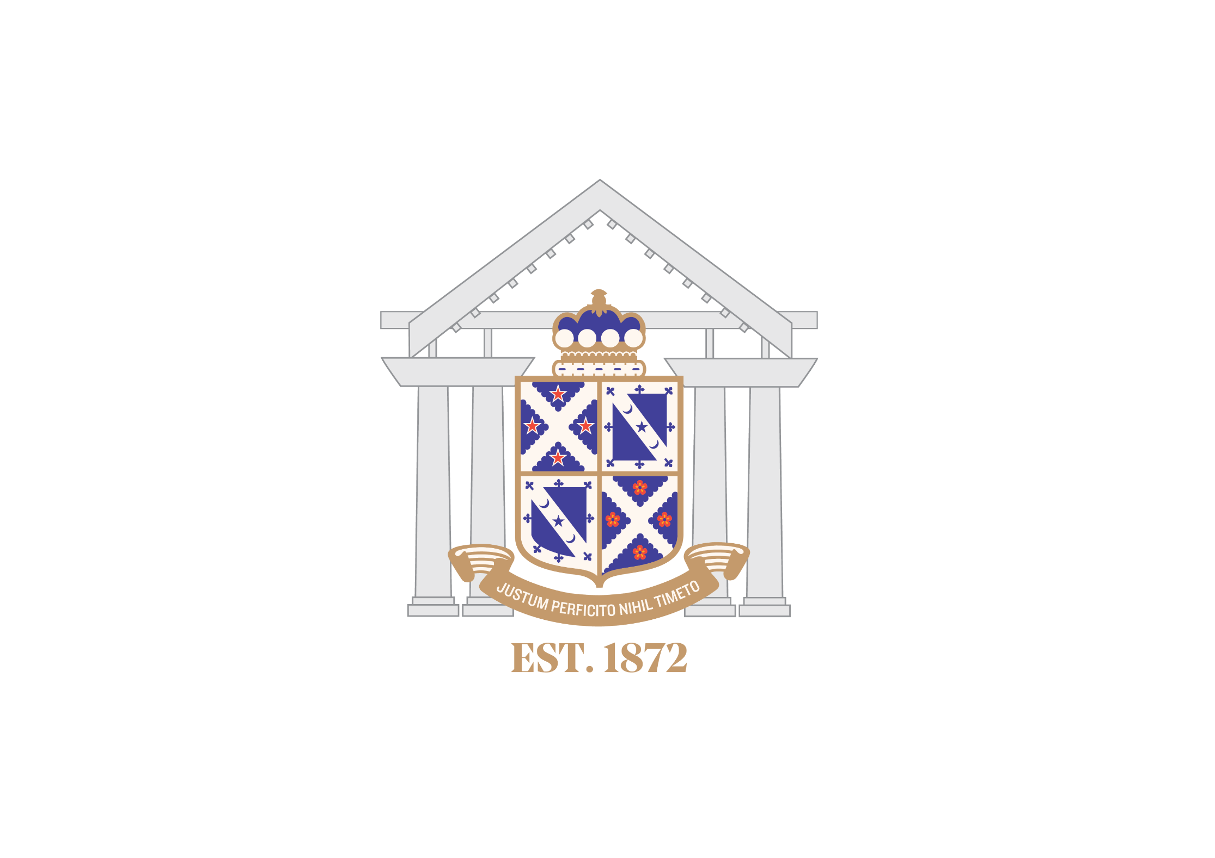

National U15 Rugby Invitational Tournament

Hosted by Napier Boys’ High School

Supported by HB Rugby

2-6th September 2019

Welcome

On behalf of Napier Boys’ High school, welcome to the 2019 U15 Secondary Schools Tournament. For those out of town, welcome to the beautiful Hawkes Bay - We hope you enjoy your time here and what our city has to offer.

We are delighted to welcome the 15 visiting schools in what is a unique tournament entering its 36th year. There is rich rugby history in all schools and the passion for the game is incredible. This tournament provides young men with a wonderful opportunity to compete against high calibre teams.

Enjoy your time here, and the experience - remember why we are here and please let us know if we can help in any way.

**NBHS Rugby & Sports Department**

Contacts

Tournament Director: Brendon Ratcliffe – 0272772096

Tournament Logistics: Kirsty McCallum – 0273806528 (kmccallum@nbhs.school.nz)

Tournament Central: NBHS Rugby Pavilion

Tournament results and update: Tournament Facebook page - <https://www.facebook.com/nationalU15rugbytournament/>

* Updated results will be posted on the Facebook page after a completed round.
* Wednesday – Fridays draw and field allocations will be posted on the Facebook page by 4pm on the day prior.

Field Locations

Each team will be allocated 8 Chairs which will be placed at the end of each field. Please DO NOT move these, or return them anywhere – they will be collected and distributed each day for you.

Please respect the grounds that you are playing on, treat them as you would your own school fields. There are numerous rubbish bins that will be provided – please use them!

There will be NO parking in Napier Boys High School Grounds, you are able to drive in the Te Awa Driveway and into the Pavilion area to DROP OFF only and then straight back out to park on Te Awa Avenue. We have a construction site near the rugby fields and this must be clear of parked cars for the entire week.

If there happens to be a SCHOOL Fire Alarm – the game on FIELD 2 will be temporarily stopped due to this being the assembly area.

**1. Napier Boys High School Fields:** Entrance via Te Awa Avenue, Parking on roadside

A – Upstairs: Pavilion (Tournament Managers Base), Downstairs: Changing Rooms

B – School Office

4 – Team Warm up Area #4

5 – Team Warm up Area #5

**2. Napier ‘WHITMORE PARK’ Fields:** Entrance via Douglas McLean Avenue, Parking in Carpark

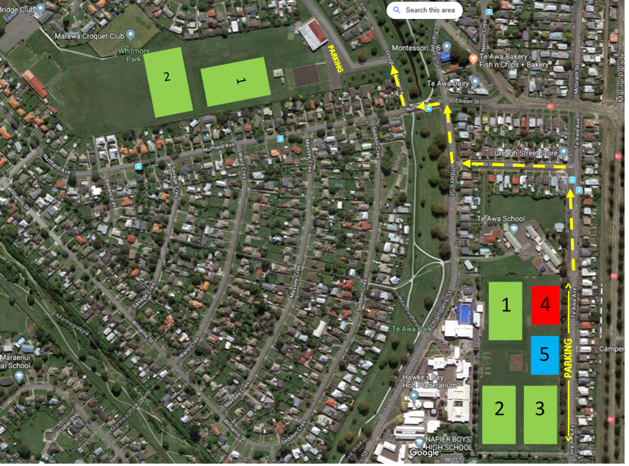

Changing Rooms

Allocations for changing rooms will be distributed closer to the time. These changing rooms are for PRE GAME only. The showers are not available due to having another team in the changing room for the next game. You MUST clear the changing room before your game starts and leave nothing in there as the next games team will be in there when your game is still underway. There are the following number of changing rooms at each location

1. **Napier Boys High School Fields:** 
   1. There are 4 Changing rooms available at each time for Fields 1 & 2
   2. There will be portable changing rooms (popup tents) for those playing on field 3. Please note – there is no security here for these.
2. **Whitmore Park Fields:**
   1. There are 4 Changing rooms available at each time.

Tournament Rules

**Team and game conditions**

Squads can have up to 24 Players.

* All 24 may be stripped for any one match.
* Squads must have at least 4 trained front rowers.
* Up to 9 substitutions can be made during a match.

Unless stated all games will be played according to World Rugby Law of the Game and NZ Rugby Domestic Safety Law Variations.

All Pool games shall consist of two 22 ½ minute halves with a five minute halftime break.

All subsequent games (Day 3 onward), will be played with two 30 minute halves with a five minute halftime break.

**Pool Matches**

At the completion of Pool matches, teams will be ranked 1st, 2nd, 3rd and 4th in their respective Pools.

In Pool matches, teams will earn:

* 4 points for a win
* 2 points for a draw
* 1 point for a loss of 7 points or less
* 1 point for 3 or more tries scored

No extra time is played in Pool matches if the score is tied at full time.

If the teams are equal on competition points at the end of Pool play, the following criteria will be used, in sequence until the teams can be ranked.

**Ranking process**

When two teams tie on competition points the team that won their encounter will be allocated the higher ranking. If that game was drawn, the higher points differential (total points scored minus total points conceded) from pool games will determine the ranking.

If more than two teams are tied on competition points, then point’s differential shall be used to determine the rankings. Ties still not broken:

* Resolved by comparing the number of tries scored in Pool matches. The higher tally of tries scored is allocated the higher ranking. If still tied.
* A coin toss by Tournament Management, will determine the higher ranked team.
* All disputes shall be referred to Tournament Management who will make the final decision in line with the above rules.
* Extra-time for quarter, semi and finals
* In order to get a clear winner in each game the referee shall apply the following rules in the event of a drawn game:

There shall be two x 5 minute spells of extra time played with one minute turn around between extra time halves. Teams will play in the same direction as the first half of the match. The team that kicked off to start the match will kick off to start extra time.

If, at the conclusion of extra time, the scores are still tired, the following criteria will be applied in sequence until a winner can be determined.

* The team that scored the most tries in the game.
* The team that scored the first try in the game.
* The team that scored the first points in the game.

If the score is nil-nil, the toss of a coin by the captains under the supervision of the Tournament Management.

**Judiciary**

* Red Card. A Player shown a Red Card shall be automatically suspended for 1 game. A Judicial Hearing will be conducted at which the length of suspension will be determined. The Judicial Committee is able to impose any suspension.
* If there is a conflict of interest where someone from the defendant’s school is represented on the Judiciary, they will be replaced with someone from another school.
* The accumulation of 3 Yellow Cards by an individual player will be treated as a Red card. The process for a Red Card, outlined above will apply.
* Blue Card, Any player issued a blue card will undertake the full NZRU return to play protocols – minimum 23 day stand-down

**Haka Protocols**

* A team that intends to perform a pre-match haka must inform the opposition and referee when they arrive at the venue. This is the responsibility of the manager.
* A team receiving a haka must stand behind the 10 meter line and must not advance.
* A team performing a haka must not advance over their 10 meter line. Where a team’s haka includes movements towards the opposition it must begin behind their own 10 meter line and they must not advance over that 10 metre line.

**Sideline Protocols**

ALL team support are required to be positioned behind their dead ball line throughout the game. This includes water and medical personnel.

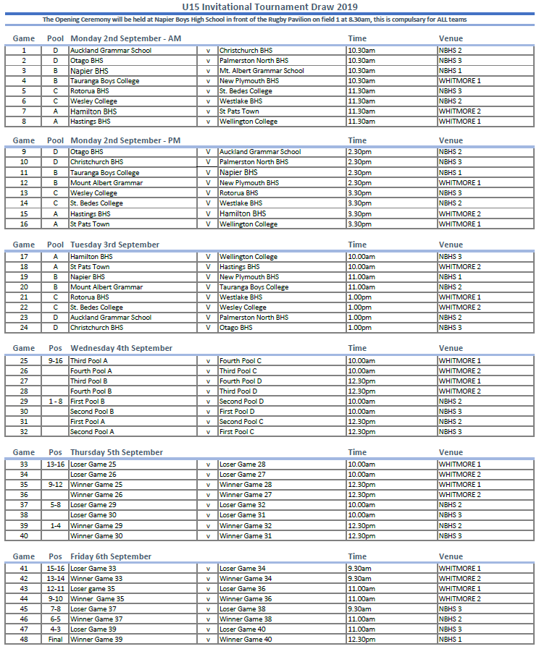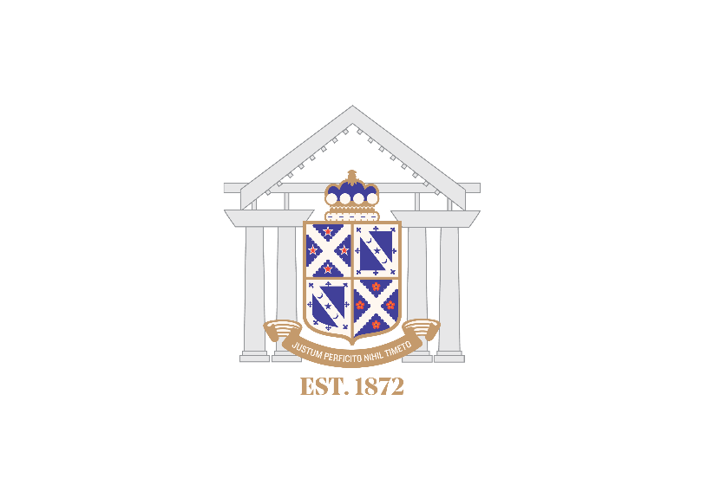

**Hamilton Boys High School**

Hamilton Boys’ High School is a state boys’ school of approximately 2200 boys with a proud history in the city of Hamilton and an outstanding reputation for nurturing personal, academic and co-curricular excellence.

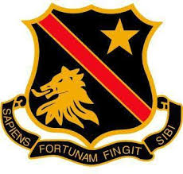In 2019 we have 22 rugby teams playing in both the Super 8 competition as well as the Waikato Secondary Schools competition. We also have annual traditional fixtures against Auckland Grammar, New Plymouth BHS and Tauranga Boys College.

Some of our old boys who are currently participating in professional rugby teams around the world include, Tawera Kerr-Barlow, Sevu Reece, Henry Speight, Toby Smith, Regan Ware and Isaac Te Tamaki.

|  |  |
| --- | --- |
| **Team Colours** | |
| Jersey: | Red with Black |
| Shorts: | Black |
| Socks: | Black and Red |
| Alternate: | Black with Red |

|  |  |  |
| --- | --- | --- |
| **Team** | | |
| Reegan Aarsen | Levi Hazelton | Noah Smiler |
| Joshua Blaikie | Nathan Jordan | Payton Spencer |
| Tanish Bowden | Inga Kokohu | Liam Strum |
| Jaime Brewer | William Martin (VC) | Jack Tuck |
| Caylus Brighouse | Malachi Misa | Aki Tuivailala |
| Tai Cribb | Renata Palmer | Feofa Aki A Kakau Jr Tupou |
| Abraham Harrison | Karage Poihipi | Ponvalu Tupoufalepouvalu |
| Joel Hazelton © | Brodie Robinson | Manai Williams |

|  |  |
| --- | --- |
| **Team Management** | |
| Coach | Todd Miller |
| Manager | Luke Katene |

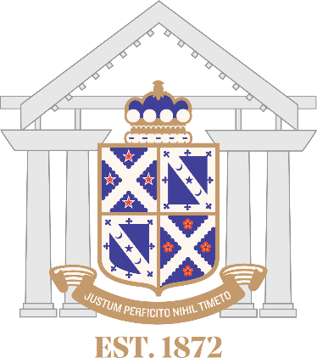

**Napier Boys High School**

Napier Boys’ High School was founded in 1872, and is one of the oldest schools in New Zealand. It has a proud record of academic achievement, sporting prowess, cultural excellence and grounding in traditional values. We have been past champions of this tournament on three occasions 2002, 2003, and 2004.

We are currently 1240 students strong, with over 800 involved in extra-curricular activities. We currently have 16 rugby teams. Brad Webber is our most recent All Black, with old boys Ihaia West, Gareth Evans, Zac Guildford, Richard Buckman and Sam McNicol all members of this year’s Super 18 squads. Tim Farrell and Pouri Rakete-Stones both played in the World Champion Under 20 team previously, with William Tremain (Grandson of Kel Tremain). All the above mentioned have played at the Under 15 tournament.

Napier Boys’ High School has a proud tradition of success, on and off the field. The rugby program is underpinned by the simply philosophy that ‘better young men make better NBHS rugby players’.

|  |  |
| --- | --- |
| **Team Colours** | |
| Jersey: | Blue with White Hoops |
| Shorts: | White |
| Socks: | Blue with White Hoops |
| Alternate: | Sky Blue |

|  |  |  |
| --- | --- | --- |
| **Team** | | |
| Kade Barham | Tulitalual Faleiva | Max Pirie |
| Cory Berkett | Telea Faumui | Max Ratcliffe © |
| Kaitiaki Broughton | Ezekiel Greeks | Harry Robinson |
| Gus Brown | Manaaki Hunt | Joel Russell |
| Luke Chamberlain | George Manson | Tim Slabbekoorn |
| Tyrone Chrystal | Jared Martin | Tasman Soanai |
| Adam Curran | Jahdyn Moulder | Te Aotaki Edmonds |
| Jake Evans | Korie Paio |  |

|  |  |
| --- | --- |
| **Team Management** | |
| Coach | Vili Malaitai & Farrell Chrystal |
| Manager | John Stapley |
| Physio/Support | Colin Tutchen |

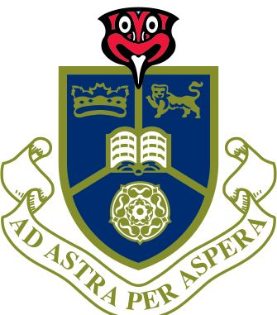

**Rotorua Boys High School**

**Founded:** 1927

**Motto:** Ad Astra Per Aspera – To the stars through hard work.

**Maori:** Whaia Te Iti Kahurangi – Search for great things.

**National 1st XV Champions:** 1998, 2002, 2003, 2015

**Moascar Cup Holders:** 2003-2004

**Sanix World Youth Champions:** 2003, 2004

**Bay Of Plenty Champions In Super 8 Era:** 1998-2003, 2005-2012, 2014-2017

**Super 8 Champions:** 1998, 2001

Rotorua Haka: About the concept of Raukura which was a Maori accolade sought after and bestowed upon a deserving individual for excellence. The RBHS haka expresses the urge to succeed through pure determination, dedication and discipline. It express a commitment to the Marae, the mana and prestige of oneself and the school. It strives to leave an impression

Rotorua All Blacks: Trevor Berghan, Neville Black, Mike Delany, Tom Donnelly, Alan McNaughton, Liam Messam, Craig Newby, Arthur Stone, Te Toiroa Tahuriorangi

|  |  |
| --- | --- |
| **Team Colours** | |
| Jersey: | Red and Navy |
| Shorts: | Red |
| Socks: | Navy and Red |
| Alternate: | Red |

|  |  |  |
| --- | --- | --- |
| **Team** | | |
| Leeshaye Orono-Te Huia | Calan Wiremu | Xavier Murray |
| Mathieu Boynton-Rata | Liliano Sabatini | Whetu Bennett-Thomas |
| Ethan Jonas | Nacani Batidravu | Broc Maki |
| Maru Maniapoto-Whitiora | Jason Harris-Kameta | Darryl Walker |
| Todd Story | Te Hamana Te Aute | Moai Tihi |
| Taumanu Walker | Waisake Salabiau | Koan Hemana |
| Brooke Mitchell | Kody Betham | Takakopiri Whareaorere |
| Tamakaimoana Whareaorere | Maddison Rosanoski | Joeseph O’Leary |

|  |  |
| --- | --- |
| **Team Management** | |
| Coach | Jeremy Te Huia |
| Manager | Bruce Buckton |

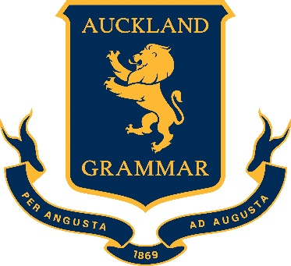

**Auckland Grammar School**

Auckland Grammar School is a state boys’ school established in 1869 and has a current roll of approximately 2550 students. The School prides itself on its academic, musical, cultural and sporting excellence, with many of its Old Boys having made significant contributions in these fields.

The School has a rich history in New Zealand Rugby, producing 52 All Blacks, more than any other school. Notable All Black greats include, Wilson Whineray, Kel Tremain, Gary and Alan Whetton, Grant Fox, Doug Howlett and current All Black Reiko Ioane. Auckland Grammar entered 16 rugby teams in the 2019 season, all coached and managed by masters at the school.

The School has a strong school spirit where students strive for their best in all areas. Sporting success over the years can be attributed to the dedication of a large number of very competent and highly motivated staff, excellent facilities and the sportsmen themselves.

|  |  |
| --- | --- |
| **Team Colours** | |
| Jersey: | Navy blue, gold collar |
| Shorts: | Navy blue, gold stripe |
| Socks: | Navy blue, gold tops |
| Alternate: | Navy blue, gold and white hoops |

|  |  |  |
| --- | --- | --- |
| **Team** | | |
| Luatangi Vatuvei | Eddie Chaytor | Torah Apineru |
| Alex Tea | Cullen Grey | Cameron Reeves |
| Josh Tepai | George Tingey | Lenny Amosa |
| Blake Manning © | Jole Naufahu © | Feleti Saafi |
| Dougal Rutherford-Levien | John Fineanganofo | Lachlan Mailei |
| Ben Thomson | Hawaiiki Wihongi | Clinton Carter |
| Kalem Tia | Riley Williams | Natanielu Hunt |
| Timothy Vaka | Kasaloma Ahokovi |  |

|  |  |
| --- | --- |
| **Team Management** | |
| Coach | Daniel Reddish |
| Manager | Justin Boroughs |



**Christchurch Boys High School**

The School was founded in 1881 in the central city and was moved to its current location in the suburb of Riccarton in 1926. Throughout its history, rugby has been a major focal point of the school. This is no better emphasised than in its annual fixture against Christ’s College, which is now in its 138th year. Christchurch Boys’ High School is also proud to be one the founding schools of the National Under 15 Tournament.

The school has produced 46 All Blacks, the most recent being Anton Lienert-Brown, Matt Todd, Brodie Retallick, Luke Romano, Colin Slade, Owen Franks, Ben Franks and Daniel Carter. The school currently caters for 22 rugby teams ranging from Under 13 to First Fifteen and is arguably the most dominant school in the top of the South Island, having won the Crusaders competition more than any other school.

The 1st XV were the National 1st XV title holders in 2004, 2005 and 2006. They also won the Sannix International 1st XV Rugby Tournament in Japan in 2005 and 2006. The schools Under 15 team won the National Tournament in 2010 and 2017 and looks forward to the opportunity and challenge of competing at this year’s tournament.

|  |  |
| --- | --- |
| **Team Colours** | |
| Jersey: | Blue and Black hoops |
| Shorts: | Black |
| Socks: | Black with Blue top |
| Alternate: | White with Blue and Gold trim |

|  |  |  |
| --- | --- | --- |
| **Team** | | |
| Max Ansell | Marli Hetutu | Maximus Ogata-johnston |
| Ari Barnes | Dementry Higgins | Joshua Pickles |
| Martino Boi | Corbin Hooper | David Rogers |
| Oliver Burra | Benjamin Jones | Benjamin Scott |
| Jack Busch-ward | Manumaua Letiu | Angus Smith |
| William Chunn | Joe Mcleod | Hoani Stewart (VC) |
| Samuel Forster © | Mitchell Mcmillan (VC) | Preston Sweney |
| Thomas Gibson | Cameron Murray | Luca Tracey |

|  |  |
| --- | --- |
| **Team Management** | |
| Coach | Rob Smith |
| Manager | Phil McKay |
| Physio/Support | Phil Watson |

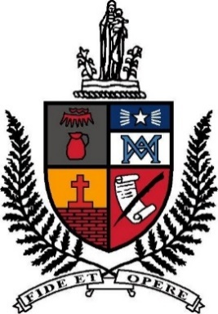

**St. Bedes College**

St Bede’s College has a long and proud Rugby tradition stretching back to the establishment of the school in 1911. Each year the school produces fourteen Rugby teams that compete successfully in every CRFU age group grade. While the College has won the Schools’ 1st XV title 23 times going back to the first in 1923, it has been in more recent seasons that they have been most successful.

The 1st XV has been the Crusaders’ Region Secondary Schools’ Rugby champions five times in recent years (The Press Cup 2008 – 2011 and UC Championship 2015) while also having been to the Top Four competition on four occasions (2008 – 2011), finishing second in 2009.

A number of the school’s players have selected for New Zealand Schools and Under 20 honours and are following in the footsteps of the twelve Bedean All Blacks – the most recent being Elliot Dixon. As a school we look forward to cheering on many others who are about to embark on their Super Rugby or National Provincial careers.

|  |  |
| --- | --- |
| **Team Colours** | |
| Jersey: | Black with Red Collar |
| Shorts: | Black |
| Socks: | Black with Red Top |
| Alternate: |  |

|  |  |  |
| --- | --- | --- |
| **Team** | | |
| Andre Sula © | Val Cowan | Genesis Mumuta |
| Elliott Prendergast (VC) | Samuel de Roo | Ben O’Donovan |
| Campbell Allison | George Gunn | Amby Pulega |
| Jonty Blacklow | Isaac Hutchinson | Cameron Rawlings |
| Josh Borcoskie | Christian Ioane | Harris Roberts-Tuahuru |
| Roan Brown | Oliver Lawry | Tanner Stowers-Smith |
| Dillon Coakley | Riley Lucas | Keegan Thomas |
| Max Coltman | Hekeawai McDermott | Declan van Wyk |

|  |  |
| --- | --- |
| **Team Management** | |
| Coach | Diarmuid McMahon |
| Coach | Nick Ryan |
| Manager | Jon McDowall |

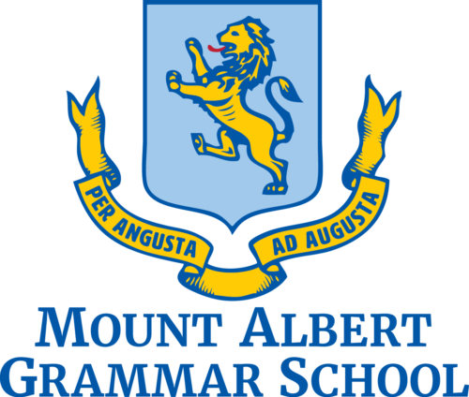

**Mt. Albert Grammar School**

Mount Albert Grammar School (MAGS) is a coeducational school of approximately 3100 students. MAGS has a proud history in Rugby winning the Auckland 1A 1st XV title 23 times and the New Zealand Top 4 title 3 times.

In 2019 we have 9 boys teams and 1 girls 10’s team. In the past four years we have had 7 junior All Blacks which include Jack Goodhue, Josh Goodhue, Ezekiel Lindenmith, Sam Slade, Caleb Clarke, Waimana Reidlinger-Kapa and Robert Cobb.

The most recent All Blacks through MAGS include Jack Goodhue, Nepo Laulala and Stephen Luatua. The most famous players through the school include Sonny Bill Williams Andrew Blowers and Sir Bryan Williams who continues today to be an inspiration to all at MAGS. The school’s number one field is named in his honour.

|  |  |
| --- | --- |
| **Team Colours** | |
| Jersey: | Light blue and gold hoops |
| Shorts: | Dark Blue Shorts |
| Socks: | Light blue and gold hoops |
| Alternate: | Dark blue and light blue jersey |

|  |  |  |
| --- | --- | --- |
| **Team** | | |
| Jackson Absolum-Leuluso’o | Tevita Folau | Te Waaka Popata-Henare |
| Kyan Alo | Ben Hellriegel | Riki Ruben |
| Juelz Baker | Taonui Henry | Ben Skelton |
| Liam Chapman | Tregan Letiu | Reuben Stewart |
| Joshua Collins | Nate Murray | Rhys Tagi |
| Montell Falakoa | Noen Okesene | Jayedon Ulaula-Ieremia |
| Lima Fatu | Jett Patea | Jack Veldkamp |
| Spinx Fiatau Kauhiva | Arius Percival | Hugo Young |

|  |  |
| --- | --- |
| **Team Management** | |
| Coach | Richie Folomu, James Collins |
| Coach | Cale Baker |
| Manager | Rita Fatu |

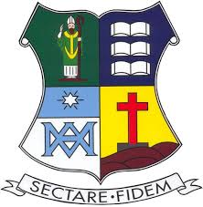

**St Patricks College**

Saint Patrick’s College is a Catholic Integrated Boys’ school situated on the coast in Kilbirnie, Wellington. **The college was founded in 1885 by the Marist Fathers (Society of Mary) and is the oldest Catholic Boys’** College in New Zealand. We have over 800 students from many different ethnicities who love the sense of belonging and the sprit that is unique at Saint Patrick’s

The college prides itself on its academic, cultural, musical and sporting excellence. Our traditional rugby fixtures include Wellington College, St Patricks Silverstream, Rongotai College, Hato Paora Fielding and St Johns College Hastings. St Patricks U15 side was finalists in the Wellington zone competition this year. The school has produced a number of All Blacks, Jerry Collins and Super Rugby players, the most recent being Matt Proctor, Billy Proctor and Sefo Numia for the Hurricanes.

|  |  |
| --- | --- |
| **Team Colours** | |
| Jersey: | Royal Blue, White Hoops |
| Shorts: | Blue |
| Socks: | Blue and White Hoops |
| Alternate: | Black and Grey |

|  |  |  |
| --- | --- | --- |
| **Team** | | |
| Jack McKelvey | Dallas Natoli | Charlie Pothan |
| Saalesa Seumanufagai | JJ Peo | Noah-Sea Nui |
| Ephesian Pedro Ramese | Brandon Vowels | Anthony Fale |
| Jack Pothan | Mark Tyrell | Jayde Burns |
| Semisi Tautau | Calum Koebergh | Daniel Tafili |
| Jordan Chapman | Aethan Tuisila | Elysium Tolova’a-Stanley |
| Khan Love | Francis Mettrick | Viliami Masila |
| Jeremiah Collins © | Solomona Vaka | Noah Kalolo |

|  |  |
| --- | --- |
| **Team Management** | |
| Coach | John DeGregorio |
| Manager | Alastair M. von Boom |

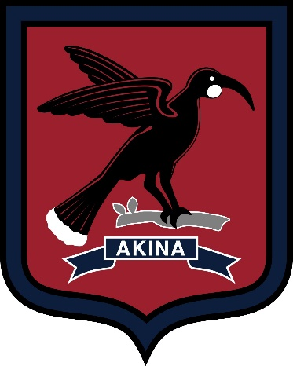

**Hastings Boys High School**

Hastings Boys' High School was founded in 1904. Originally titled the Hastings Borough School it became the Hastings District High School with Mr L.F. Pegler appointed Headmaster. In 1956 Hastings District School split to become Hastings Boys' and Hastings Girls' High Schools.

The 2017 Rugby season was the most successful in the school's history with the 1st XV winning the Barbarians National 1st XV title. Six of that team were selected in the New Zealand Secondary Schools rugby team. Devan Flanders then went on to play a pivotal role for New Zealand at rugby's under-20 World Championship in France. Eight of the team have now been selected in various teams competing in the 2018 Mitre 10 Cup competition.

In 2018 the current 1st XV competed in and were runners up in the Sannix World Youth Rugby Tournament in Fukuoka, Japan. With the foundations of the school rugby programme, built around the Junior Academies, based on our philosophy of hard work, respect and team spirit, the school is well placed for future success. The holistic approach to development is paramount at Hastings Boys' to ensure rugby playing students' aspirations are met in a well-balanced, caring environment.

|  |  |
| --- | --- |
| **Team Colours** | |
| Jersey: | Red/Navy Stripe |
| Shorts: | Navy |
| Socks: | Navy with Red Top |
| Alternate: | Red/Navy/White Stripe |

|  |  |  |
| --- | --- | --- |
| **Team** | | |
| Naverone TeRini | Rylee Ward | Lewis Andrews |
| Vikta Tevita (VC) | Koby Deacon | D Angelo Etika |
| A one Lolofie | Meytell Kara | Derek Faavae |
| Rico Harris | Bryson Ioane | TJ Vekene |
| Josh Leach | Troyden Bird © | Ollie Ritchie |
| Bonham Edwards | Alex Dickey | Izaiah Tuliau |
| Junior Setu | Tamati Te Pou | Tali Ioasa |
| Ned Saifiti | John Palu | Phortre Gurneck |

|  |  |
| --- | --- |
| **Team Management** | |
| Coach | Matt Robertson |
| Manager | Quentin Crawford |



**Tauranga Boys College**

Tauranga Boys’ College has a proud tradition of sporting achievement across a wide variety of sports. There are many world champions, from Mahe Drysdale to Peter Burling, along with many other national representatives.

Tauranga Boys' College is involved in the Super 8 North Island Boys’ Schools competition and always perform with distinction in all competitions. Players who have gone on to higher honours over the recent years include All Blacks: Royce Willis, Adrian Cashmore, Daniel Braid, Tanerau Latimer, Jarrad Hoeata, Nathan Harris, and Sam Cane while Charles Baxter, Jason Hona and Lance McDonald have all played New Zealand Sevens.

A number of other recent old boys have played Super 15 Rugby including Luke Braid, Aidan Ross, Te Aihe Toma and Jeff Thwaites.

The First XV has held the Moascar Cup six times, the latest being in 1995. We partake in regular international tours, most recently to the UK and Argentina, so rugby is in good heart at Tauranga Boys' College.

|  |  |
| --- | --- |
| **Team Colours** | |
| Jersey: | Navy Blue with White collar |
| Shorts: | Navy Blue |
| Socks: | Navy Blue and White collar |
| Alternate: | White |

|  |  |  |
| --- | --- | --- |
| **Team** | | |
| Jack Anderson | Josh Robb | Reuben Irwin |
| Matthew Stewart | Jackson Le Pou | Tupaea Mika |
| Aoturoa Seeling | Hunter Tatham-Tahere | Finn O’Brien-O’Loan |
| Josh Elmsley | Kase Meyer | Henry Mitchell |
| Grady Forbes | Xavi Taele | Josh Savage |
| Reuben Palmer | Sione Lasike | Reef Newdick |
| Fain Hammond | Elias Marks | Akuhata Hunia |
| James Haua | Kanye Jones | William Harris |

|  |  |
| --- | --- |
| **Team Management** | |
| Coach | Jeff Robb |
| Coach | Regan Ward |
| Manager | Grant Mitchell |

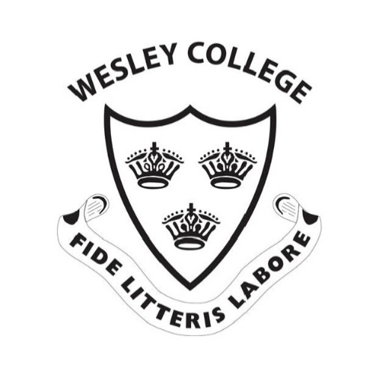

**Wesley College**

Set amidst rolling farmland and perched above well-groomed sports fields, Wesley College has a special place in the life of New Zealand and Te Haahi Weteriana. It is the country’s oldest registered secondary school. The roll of Wesley College’s famous old boys hints at strong currents that flow through the school: cultural identity, sporting success, and academic achievement. Notable alumni include Jonah Lomu, actor Temuera Morrison, Oscar winner Richard Taylor, former Children’s Commissioner Roger McClay, and the first Prime Minister of the Solomon Islands Sir Peter Kenilorea.

Wesley College took its current form through the amalgamation of two schools, one for young Maori and the other for the children of missionaries working in the Pacific. It shifted from Three Kings, Auckland to its current site at Paerata, near Pukekohe, in 1922. While it is non-sectarian, a key element of the college’s charter is to maintain the ethos of contemporary New Zealand Methodism.

|  |  |
| --- | --- |
| **Team Colours** | |
| Jersey: | Black with a white pin stripe |
| Shorts: | Black |
| Socks: | Black and white |
| Alternate: | Red and White or Blue and white - both hoops |

|  |  |  |
| --- | --- | --- |
| **Team** | | |
| Donny Afimeimounga | Makasini Soane | Taipa-Kihi Reco |
| Joseph Afimeimounga | Mau-Hinkes Apai | Tali’ai Sam |
| Esera Lenn | Nicholas Aj | Taufa Aj |
| Falekaono Kelepi | Otuhiva Zane | Tuisuva Sekove |
| Hana Kurtis | Paea Christian | Tolutau Junior |
| Kingi Cace | Peni Vevesi | Wickman-Rairoa Romatt |
| Kama David | Puamau Uai | Yaovoli Christopher |
| Lotaki Dorian | Repia Shane | Feihoko Fasi |

|  |  |
| --- | --- |
| **Team Management** | |
| Coach | Jamie Gilbert Clark |
| Manager | Kapara Emery |

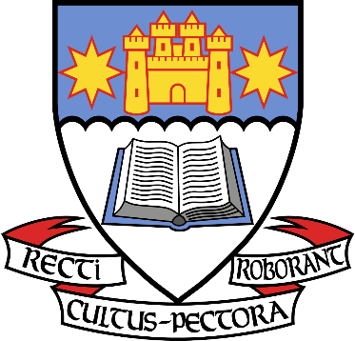

**Otago Boys High School**

Otago Boys’ High School was founded in 1863 and is one of the oldest state boys’ schools in New Zealand. A rugby match reported in the Otago Daily Times played between Otago Boys’ and an Otago University team in 1871 is accepted as the founding year for our Rugby Club and the beginning of OB’s passion for the great game. Incidentally the match was declared a draw after two days of playing.

The First XV are consistently ranked as one of the top teams in the country making the top 4 finals from 2012-2015. The school has also produced more New Zealand Secondary School and New Zealand Barbarians players than any other school over the period 2011-2018.

Otago Boys’ High School has produced 23 All Blacks. The most famous being recent All Black captain Richie McCaw. Other notable All Blacks are Byron Kelleher, Wyatt Crockett, Ken Stewart and Charlie Saxton.

|  |  |
| --- | --- |
| **Team Colours** | |
| Jersey: | Blue and White Hoops |
| Shorts: | Blue |
| Socks: | Blue and White |
| Alternate: | Blue, White and Red |

|  |  |  |
| --- | --- | --- |
| **Team** | | |
| Rauvama Akauola | Hamish Faulks | Moana Takataka |
| Petelo Amato | Sofa Fesolai | Michael Talalima |
| Jacob Bolwell | Cody Glover | Christopher Webber |
| Ashton Booth | Dylan Harris | Isaiah Mafi |
| Adrian Branzuela | Symon Maguire | Cruz Wallace |
| Cody Campbell | Charlie Mathias © | Jordan Dale |
| Will Challis | Robert McIvor | Pheonix Tapatu |
| Will Coggan | Oliver Sabiston | Jacob Waide |

|  |  |
| --- | --- |
| **Team Management** | |
| Coach | John Faulks |
| Manager | Brett Challis |

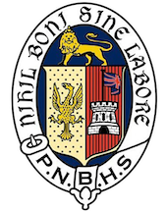

**Palmerston North Boys High School**

PNBHS runs one of the most extensive sporting programmes in New Zealand and while we are extremely proud of our first team results, the opportunity exists to compete at any level in the extensive list of sporting codes offered at our School. Pride, passion and sportsmanship are key ingredients of the School’s sporting ethos which is instilled in every young man.

‘Nihil Boni Sine Labore’. Nothing Achieved Without Hard Work.

PNBHS has a proud rugby history competing in the Super 8, National knockout competitions and traditional interschool matches that go back many decades. Rugby has been a huge part of PNBHS since 1902 when the school was founded.

Many former PNBHS rugby players have gone on to higher honours such as Liam Squire, Rob Thompson, Aaron Cruden, Bruce Hemara, Liam Mitchell, Lifeimi Mafi, Jamie Booth, Jackson Hemopo, Ngani Laumape, Kurt Baker, Craig Wicks, Hadleigh Parkes, Mark Finlay and Emosi Koloto.

|  |  |
| --- | --- |
| **Team Colours** | |
| Jersey: | Blue & white hoops |
| Shorts: | Blue |
| Socks: | Blue & white hoops |
| Alternate: | Blue jersey |

|  |  |  |
| --- | --- | --- |
| **Team** | | |
| Telson Liuvaie | Alex Boblea | Sam Lalogafau |
| Manu Latu | Maraki Aumua | Byrin Nikolajenko |
| Javahn Stevenson | Toby Gullery | Jake Donovan |
| Nasi Manu | Tayne Harvey | Sione Latu |
| Finn Coan | Jack Gordon | Livai Stevenson |
| Max Deighton | Angus Lyver | George Ellingham |
| Joe Simpson - Smith | Sam Coles | Fletcher Carpenter |
| Zane Poole © | Sidney Diamond | James Parkinson |

|  |  |
| --- | --- |
| **Team Management** | |
| Coach | Jacob Meehan |
| Manager | Duncan Cameron |

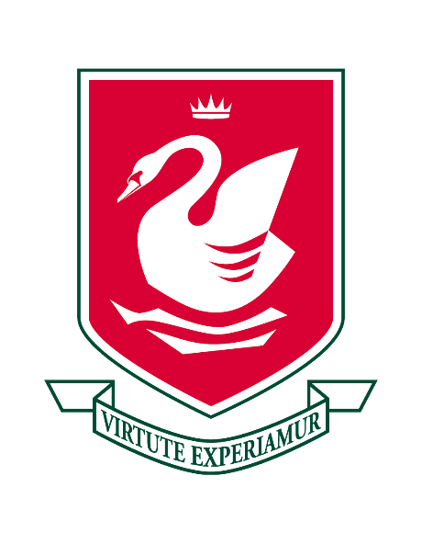

**Westlake Boys High School**

Westlake Boys High School is an all boys school located near Takapuna on Auckland’s North Shore. It has a distinguished academic record throughout its history and now matched with a sports, arts and music pedigree to be the envy of many of its rivals.

Sport is now a large component of the curriculum, where it views cricket, rowing, basketball, badminton, squash and football as a success on the national stage. Rugby Union has long been a strength in the North Harbour region, but developments have catapulted the sport into more of a focus on the wider Auckland scene. Winners of the Nth Harbour 1A competition 16 times in the regions 34-year history, motivates the school to continuously search for improvement outside its boundaries. In the last 4 seasons one of the school’s Under 15 teams has been invited to play in the Auckland A competition and improvements have been noticeable despite not reaching the semi-finals. Inclusion into this prestigious tournament last year was another step toward enhancement of the rugby program.

Westlake Boys has over 300 boys playing rugby union weekly which consists of 11 teams in 2019, including six junior teams.

Westlake has produced 5 All Blacks, Frano Botica, Ron Williams, Dean Kenny, Nick Evans and Luke McAllister. Other international representatives have been Michael Harris, who won selection into the Australian Wallabies and Taione Vea has represented his native Tonga.

|  |  |
| --- | --- |
| **Team Colours** | |
| Jersey: | Red, white and green horizontal stripe |
| Shorts: | Black |
| Socks: | Red, white and green horizontal stripe |
| Alternate: | Green jersey with white hoops |

|  |  |  |
| --- | --- | --- |
| **Team** | | |
| Cody Beale | Ethan Holt | Kobe Pola |
| Tom Bradford | James Hopwood | Levon Pure |
| Cameron Christie | Jack Lee | Elijah Rasmussen |
| Tristyn Cook © | Kurtis MacDonal | Ulrigh Snymna |
| Liam Halpin | Logan McAvoy | Jayden Tau-Harris |
| Jayden Harris | Ollie McDowell | Xieden Urlich |
| Jack Harrison | Charlie Milford |  |
| Nikau Hawkes | Daniel Paulsen |  |

|  |  |
| --- | --- |
| **Team Management** | |
| Coach | Nick Elrick |
| Coach | Zane Seddon |
| Manager | Natalie Marriott |

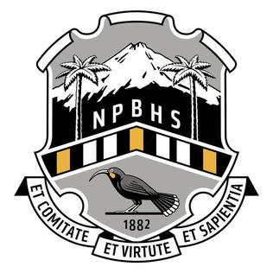

**New Plymouth Boys High School**

Since 1882 New Plymouth Boys’ High School has been leading the way in the education of boys in a world class environment. From the famous amphitheatre that is the Gully Ground, and also the stage for the incomparable full school Haka, to the impressive full school 1200 seat Ryder Assembly Hall.

NPBHS is a modern learning environment where traditional standards of achievement and behaviourare expected. The 170 Boarders are the heart of the school, not just in terms of culture and standardsbut because it is also set within the heart of 14 hectares of park like school grounds.

Rugby has played an important part in the history of the school with many notes All Blacks; Reuben Thorne, Greg Feek, Gordon Slater, Graham Mourie, Carl Hayman, Neil Wolfe to name a few. As well as present Super Rugby players such as Mitchell Brown, Lachlan Boshier and Leighton Price.

The U15 side at New Plymouth Boys’ High plays in the local TRFU competition against other local school 2nd and 3rd XV sides. It has traditionals against Auckland Grammar, Hamilton Boys’, Tauranga Boys’, Palmerston North Boys’ and Westlake Boys’ as well as the annual traditional against across town rivals Francis Douglas Memorial College.

|  |  |
| --- | --- |
| **Team Colours** | |
| Jersey: | White and black hoops with yellow trim |
| Shorts: | Black |
| Socks: | Black with white hoops |
| Alternate: | Yellow and black hoops |

|  |  |  |
| --- | --- | --- |
| **Team** | | |
| Luke McLellan | Topia Barrowcliffe (VC) | Patrick Howlett |
| Harry Theodore | Cullum Tito | Tom Doyle |
| Tyler Houpapa | Zed Stewart-Cranson | Mason Jones |
| Ropata Taylor | Jayden Anaha | Liam Day |
| William O'Donnell | Samuela Vakadula | Sirino Rova |
| Joel Turnbull | Korrbin Ahu-Skelton | Jacob Berquist |
| Jacob Mitchell © | Callis Quinn-Armstrong | Koby Smith |
| Riley Thompson | Devlin O’Loughlin | Cade Greenbank |

|  |  |
| --- | --- |
| **Team Management** | |
| Coach | Blair Corlett |
| Manager | Aaron Lock |

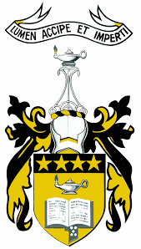

**Wellington College**

Te Kāreti Tamatāne o te Whanganui-a-Tara

Wellington College is a state boys’ school of approximately 1800 boys, situated next to the Basin Reserve and Government House in central Wellington. Established in 1867, Wellington College has built up a fine tradition of excellence, across all fields of academia, sports and the arts. In 2017 the College celebrated its 150th year of operation and hosted this tournament. The Wellington College Rugby Football Club originated in 1877 when it was first established as a support base for the development of the game at school. The club has 11 teams in 2019. It is one of the oldest registered rugby clubs in Wellington and owes much of its early development to Mr J P Firth – Headmaster (1892 – 1921).

With 35 All Blacks, Wellington College boasts the third highest number of any secondary school in the country. Recent All Blacks include Neemia Tialata, Dane Coles, Jeff Toomaga-Allen and Lima Sopoaga.

The College holds annual traditional fixtures with Napier Boys High School and Palmerston North Boys’ High School, and play in the Wellington Under 15 1st Division.  The team are the current holders of the Fr Gus Hill Cup, triumphant over St Patrick’s College, Silverstream, in the U15 Division 1 2019 Final. The team is looking forward to developing their game across matches against quality sides from across the country, following in the traditions of previous tournament winners.

|  |  |
| --- | --- |
| **Team Colours** | |
| Jersey: | Black with gold trim |
| Shorts: | White |
| Socks: | Black with gold trim |
| Alternate: | Gold jersey with black trim, white shorts, and black socks with gold trim |

|  |  |  |
| --- | --- | --- |
| **Team** | | |
| Aaifou-Aloisio, Mason | Auelua, Lochlan | Bann, Henri |
| Fletcher, Abraham | Guiney, Hugh | Hemopo-Tarawhiti, Xavier |
| Hickey, Sam | Leaupepe-Mailei, Jarvis | Liko, Shiloh |
| Miller, Angus | Opai, Isaiah | Paongo, Tofuka © |
| Porter, Max | Rere, D'Mitrius | Roffey, Arjay |
| Siolo, Tauvaga | Solomon, Stanley | Sopoaga, Devon |
| Stoney, Kyahn | Sturgeon, Harry | Takeuchi, Thoma |
| Toimata, Mathias | Tu'amoheloa, Joseph | Tuitama-Tiatia, Alopoto |

|  |  |
| --- | --- |
| **Team Management** | |
| Coach | Te Raina Richards-Coxhead, Peteli Siolo |
| Manager | Manaia Opai |
| Support | Louise Carter |

|  |  |  |
| --- | --- | --- |
| **Christchurch 1985**  **Final 14-3**  1. Auckland Grammar  2. St Andrew’s College  3. Hamilton BHS  4. Christchurch BHS  5. St Stephen’s School  6. Hastings BHS  7. Otago BHS  8. Lincoln High School  9. Shirley BHS  10. St Bede’s College  11. Christ’s College  12. Napier BHS  13. St Pat’s Town  14. Rongotai College  15. Aranui College  16. Rangiora College | **Napier 1986**  **Final 8-3**  1. Napier BHS  2. Hastings BHS  3. Otago BHS  4. Christchurch BHS  5. Te Aute College  6. St Stephen’s School  7. Auckland Grammar  8. St Pat’sTown  9. Christchurch BHS  10. St John’s College  11. Lindisfarne College  12. Rongotai College  13. Hamilton BHS  14. Havelock North High School  15. Central Hawke’s Bay  16. Colenso High School | **Auckland 1987**  **Final 12-3**  1. Auckland Grammar  2. Hamilton BHS  3. St Stephen’s School  4. Massey High School  5. Hastings BHS  6. Christchurch BHS  7. Mt Albert Grammar  8. St Pat’s Town  9. Napier BHS  10. Mt Roskill Grammar  11. Otago BHS  12. Parkway College  13. James Cook High School  14. Wellington College  15. Rongotai College  16. Shirley BHS |
| **Wellington 1988**  **Final 17-3**  1. St Stephen’s School  2. Napier BHS  3. St Bernard’s College  4. Wellington College  5. Auckland Grammar  6. Otago BHS  7. St Pat’s Town  8. St Pat’s Silverstream  9. Hastings BHS  10. Parkway College  11. Rongotai College  12. Aotea College  13. Viard College  14. Hamilton BHS  15. Christchurch BHS  16. Shirley BHS | **Dunedin 1989**  **Final 6-4**  1. St Stephen’s School  2. Auckland Grammar School  3. Otago BHS  4. Napier BHS  5. King’s High School  6. Palmerston North BHS  7. St Andrew’s College  8. Rongotai College  9. Hamilton BHS  10. McGlashon College  11. Christchurch BHS  12. Shirley BHS  13. Southland BHS  14. St Pat’s Town  15. Timaru BHS  16. Wellington College | **Hamilton 1990**  **Final 12-0**  1. St Stephen’s School  2. Otago BHS  3. Auckland Grammar  4. Hamilton BHS  5. St John’s College  6. Church College  7. Fraser High School  8. St Paul’s Collegiate  9. Napier BHS  10. St Pat’s Town  11. Hillcrest High School  12. Rongotai College  13. Christchurch BHS  14. Shirley Boys  15. Melville High School  16. Te Aute College |
| **Christchurch 1991**  **Final 18-3**  1. Auckland Grammar  2. Hamilton BHS  3. St Stephen’s  4. Otago BHS  5. Christchurch BHS  6. Wellington College  7. Napier BHS  8. St Andrew’s College  9. St Pat’s Town  10. Shirley BHS  11. Rongotai College  12. St Bede’s College  13. Mt Albert Grammar  14. Catholic Cathedral College  15. Christ’s College  16. St Thomas of Canterbury | **Napier 1992**  **Final 9-6**  1. Mt Albert Grammar  2. St Stephen’s  3. Auckland Grammar  4. Hamilton BHS  5. Hastings BHS  6. Shirley BHS  7. Wellington College  8. Christchurch BHS  9. Te Aute College  10. Rongotai College  11. Otago BHS  12. St Pat’s Town  13. Dannevirke High School  14. Napier BHS  15. St John’s College  16. Havelock North High School | **Auckland 1993**  **Final 20-0**  1. Auckland Grammar  2. Hamilton BHS  3. St Pat’s Town  4. Mt Albert Grammar  5. St Stephen’s  6. Wellington College  7. Otago BHS  8. Shirley BHS  9. Pukekohe High School  10. Rosmini College  11. Napier BHS  12. Christchurch BHS  13. Rongotai College  14. Massey College |

**Historical Record**

|  |  |  |
| --- | --- | --- |
| **Wellington 1994**  **Final 26-0**  1. Auckland Grammar  2. Palmerston North BHS  3. Otago BHS  4. Mt Albert Grammar  5. Napier BHS  6. Rongotai College  7. Christchurch BHS  8. St Stephen’s  9. Wellington College  10. St Pat’s Silverstream  11. St Pat’s Town  12. Hamilton BHS  13. St Bernard’s College  14. Aotea College  15. Hutt Valley High School  16. Mana College | **Dunedin 1995**  **Final 9-5**  1. Auckland Grammar  2. Napier BHS  3. Mt Albert Grammar  4. St Stephen’s  5. Palmerston North BHS  6. Otago BHS  7. Hamilton BHS  8. Rongotai College  9. St Pat’s Town  10. Wellington College  11. St Andrew’s College  12. Christchurch BHS  13. North Canterbury XV  14. Sassenachs Blue  15. Sassenachs Gold  16. Otago BHS | **Hamilton 1996**  **Final 22-5**  1. Auckland Grammar  2. Hamilton BHS  3. Mt Albert Grammar  4. Christchurch BHS  5. Palmerston North BHS  6. Te Awamutu College  7. St Pat’s Town  8. Forest View High School  9. Napier BHS  10. Otago BHS  11. New Plymouth BHS  12. St John’s College  13. Wellington College  14. Fraser High School  15. Cambridge High School  16. Hamilton BHS |
| **Christchurch 1997**  **Final 16-13**  1. Auckland Grammar  2. Hamilton BHS  3. Rotorua BHS  4. Christchurch BHS  5. St Pat’s Town  6. Palmerston North BHS  7. New Plymouth BHS  8. Otago BHS  9. Napier BHS  10. St Bede’s College  11. Wellington College  12. Shirley BHS  13. Mt Albert Grammar  14. St Thomas of Canterbury  15. Christchurch BHS  16. St Andrew’s College | **Napier 1998**  **Final 14-13**  1. Auckland Grammar  2. Mt Albert Grammar  3. Napier BHS  4. Gisborne BHS  5. New Plymouth BHS  6. Hamilton BHS  7. Rotorua BHS  8. Palmerston North BHS  9. Christchurch BHS  10. Tauranga Boys’ College  11. St John’s College  12. Wellington College  13. St Pat’s Town  14. Otago BHS  15. Hastings BHS  16. St Stephen’s School | **Auckland 1999**  **Final 13-12**  1. Otago BHS  2. Napier BHS  3. Wellington College  4. Hamilton BHS  5. New Plymouth BHS  6. Kelston BHS  7. Rotorua BHS  8. Palmerston North BHS  9. Auckland Grammar  10. Mt Albert Grammar  11. Christchurch BHS  12. Gisborne BHS  13. St Stephen’s School  14. St Pat’s Town  15. Otahuhu College  16. Tauranga Boys’ College |
| **Wellington 2000**  **Final 18-7**  1. Hastings BHS  2. Wellington College  3. Napier BHS  4. Hamilton BHS  5. Rotorua BHS  6. Palmerston North BHS  7. New Plymouth BHS  8. Mt Albert Grammar  9. Christchurch BHS  10. Otago BHS  11. Auckland Grammar  12. Tauranga Boys’ College  13. Porirua College  14. Gisborne BHS  15. St Pat’s Town  16. Rongotai College | **Dunedin 2001**  **Final 27-3**  1. Auckland Grammar School  2. Tauranga Boys’ College  3. Rotorua BHS  4. Hamilton BHS  5. Napier BHS  6. Wesley College  7. Otago BHS  8. Kavanagh College  9. Palmerston North BHS  10. Christchurch BHS  11. New Plymouth BHS  12. Hastings BHS  13. Wellington College  14. St Pat’s Town | **Palmerston North 2002**  **Final 14-3**  1. Napier BHS  2. Mt Albert Grammar  3. Christchurch BHS  4. Wesley College  5. Auckland Grammar  6. Palmerston North BHS  7. New Plymouth BHS  8. Hastings BHS  9. Hamilton BHS  10. Gisborne BHS  11. Rotorua BHS  12. Tauranga Boys’ College  13. Wellington College  14. Hato Paora College  15. St Pat’s Town  16. Te Aute College |
| **Napier 2003**  **Final 22-14**  1. Napier BHS  2. Hamilton BHS  3. Christchurch BHS  4. Mt Albert Grammar  5. Auckland Grammar  6. Palmerston North BHS  7. New Plymouth BHS  8. Tauranga Boys’ College  9. Wesley College  10. Gisborne BHS  11. Hastings BHS  12. Rotorua BHS  13. Wellington College  14. Massey College  15. St Pat’s Town  16. Te Aute College | **Hamilton 2004**  **Final 47-0**  1. Napier BHS  2. Gisborne BHS  3. Wellington College  4. Rotorua BHS  5. Tauranga Boys’ College  6. Palmerston North BHS  7. St Pat’s Town  8. Christchurch BHS  9. Wesley College  10. New Plymouth BHS  11. Hastings BHS  12. Mt Albert Grammar  13. Massey High School  14. Auckland Grammar  15. Te Aute College  16. Hamilton BHS | **Christchurch 2005**  **Final 20-12**  1. Christchurch BHS  2. Hamilton BHS  3. Napier BHS  4. Wesley College  5. Mt Albert Grammar  6. Palmerston North BHS  7. Tauranga Boys’ College  8. Rotorua BHS  9. Wellington College  10. Hastings BHS  11. New Plymouth BHS  12. St Bede’s College  13. Massey High School  14. St Pat’s Town  15. Auckland Grammar  16. Te Aute College |
| **Tauranga 2006**  **Final 15-0**  1. Wellington College  2. Christchurch BHS  3. Tauranga Boys’ College  4. Massey High School  5. Palmerston North BHS  6. Napier BHS  7. Hamilton BHS  8. St Bede’s College  9. Wesley College  10. Auckland Grammar  11. Otago BHS  12. Rotorua BHS  13. Mt Albert Grammar  14. New Plymouth BHS  15. Hastings BHS  16. St Pat’s Town | **Wesley 2007**  **Final 18-15**  1. Palmerston North BHS  2. Napier BHS  3. Wesley College  4. Hastings BHS  5. Hamilton BHS  6. Massey High School  7. Tauranga Boys’ College  8. St Bede’s College  9. Otago BHS  10. New Plymouth BHS  11. Mt Albert Grammar  12. Christchurch BHS  13. St Pat’s Town  14. Wellington College  15. Auckland Grammar  16. Rotorua BHS | **Wellington 2008**  **Final 20-3**  1. Mt Albert Grammar  2. Palmerston North BHS  3. Napier BHS  4. New Plymouth BHS  5. St Bede’s College  6. Wellington College  7. St Pat’s Town  8. Hastings BHS  9. Christchurch BHS  10. Hamilton BHS  11. Wesley College  12. Massey High School  13. Auckland Grammar  14. Tauranga Boys’ College  15. Rotorua BHS  16. Otago BHS |
| **New Plymouth 2009**  **Final 24-5**  1. Mt Albert Grammar  2. Napier BHS  3. Auckland Grammar  4. St Bede’s College  5. Wesley College  6. Hamilton BHS  7. Rotorua BHS  8. Otago BHS  9. Palmerston North BHS  10. Tauranga Boys’ College  11. Christchurch BHS  12. St Pat’s Town  13. Hastings BHS  14. New Plymouth BHS  15. Massey High School  16. Wellington College | **St Bede’s 2010**  **Final 14-6**  1. Christchurch BHS  2. Auckland Grammar  3. Napier BHS  4. Tauranga Boys’ College  5. Wesley College  6. Mt Albert Grammar  7. Palmerston North BHS  8. St Bede’s College  9. Hamilton BHS  10. Wellington College  11. Massey High School  12. Rotorua BHS  13. St Pat’s Town  14. Hastings BHS  15. Otago BHS  16. New Plymouth BHS | **Hastings 2011**  **Final 10-7**  1. Tauranga Boys’ College  2. Hamilton BHS  3. Auckland Grammar  4. Napier BHS  5. Palmerston North BHS  6. Rotorua BHS  7. Mt Albert Grammar  8. Hastings BHS  9. Wellington College  10. Otago BHS  11. Christchurch BHS  12. St Bede’s College  13. New Plymouth BHS  14. Massey High School  15. Wesley College  16. St Pat’s Town |

|  |  |  |
| --- | --- | --- |
| **Rotorua 2012**  **Final 38-10**  1. Mt Albert Grammar  2. Hamilton BHS  3. Auckland Grammar  4. Rotorua BHS  5. St Pat’s Town  6. Palmerston North BHS  7. Hastings BHS  8. Napier BHS  9. Otago BHS  10. Wellington College  11. Wesley College  12. Tauranga Boys’ College  13. Christchurch BHS  14. New Plymouth BHS  15. St Bede’s College  16. Massey High School | **Auckland 2013**  **Final 14-7**  1. Hamilton BHS  2. St Bede’s College  3. Mt Albert Grammar  4. Wesley College  5. Auckland Grammar  6. Napier BHS  7. Christchurch BHS  8. St Pat’s Town  9. Rotorua BHS  10. Hastings BHS  11. New Plymouth BHS  12. Palmerston North BHS  13. Otago BHS  14. Wellington College  15. Tauranga Boys’ College  16. Massey High School | **Palmerston North 2014**  **Final 27-26**  1. Hamilton BHS  2. Mt Albert Grammar  3. Tauranga Boys’ College  4. Hastings BHS  5. Auckland Grammar  6. Napier BHS  7. Otago BHS  8. St Pat’s Town  9. Wesley College  10. Palmerston North BHS  11. Rotorua BHS  12. Massey High School  13. Wellington College  14. Christchurch BHS  15. St Bede’s College  16. New Plymouth BHS |
| **Dunedin 2015**  **Final**  1.Wesley College  2. Mt Albert Grammar School  3. St Bedes College  4. New Plymouth Boys HS  5. Napier Boys High School  6. Auckland Grammar School  7. Christchurch Boys HS  8. Wellington College  9. Hamilton Boys High School  10. Hastings Boys High School  11. Palmerston North Boys High  12. Rotorua Boys High School  13. St Patricks Town  14. Massey High School  15. Otago Boys High School  16. Tauranga Boys High School | **Massey High School 2016**  **Final**  1.Auckland Grammar  2.Hamilton Boys High School  3. Otago Boys High School  4.Christchurch Boys High School  5.Rotorua Boys High School  6. St Bedes Colege  7.New Plymouth Boys HS  8. Tauranga Boys High School  9. Wesley College  10. Wellington College  11.Mt Albert Grammar School  12.St Patricks Town  13.Napier Boys High School  14. Hastings Boys High School  15.Palmerston North Boys High  16. Massey High School | **Wellington 2017**  **Final 22-18**  1. Christchurch BHS  2. Hamilton BHS  3. Auckland Grammar  4. Hastings BHS  5. New Plymouth Boys HS  6. St Bedes  7. Tauranga Boys College  8. Rotorua BHS  9. Palmerston North BHS  10. Napier BHS  11. Wesley College  12. Mount Albert Grammar  13. St Patricks Town  14. Otago BHS  15. Wellington College  16. Massey HS |
| **Auckland Grammar 2018**  **Final 17-21**  1. Hamilton BHS  2. Napier BHS  3. Rotorua BHS  4. Auckland Grammar School  5. CBHS  6. St. Bedes College  7. Mt. Albert Grammar School  8. St Pats Town  9. Hastings BHS  10. Tauranga Boys College  11. Wesley College  12. Otago BHS  13. PNBHS  14 Westlake BHS  15. NPBHS  16. Wellington College |  |  |